NARENDARAN K 240701624

Forms Design Using Zoho Creator

AIM
To create and manage a patient appointment booking form using Zoho Creator for storing patient details, medical details, and appointment scheduling and consent information.

PROCEDURE
- Create a new application in Zoho Creator for Patient Appointment Management.
- Create a form named Appointment_Booking_Form with the following three sections:
  - Patient Details – to store Patient Name, Age, Gender, Email, Contact Number, and Residential Address.
  - Medical Details – to store Referred_by, Department, Symptoms/Description (Multi Line), and Existing Conditions.
  - Scheduling & Consent – to store Preferred Appointment Date, Preferred Appointment Time, and Consent for Treatment.
- Add suitable field types such as Name, Number, Radio (Gender: Female, Male, Others), Email, Phone, Address, Single Line, Dropdown (Department, Existing Conditions), Multi Line, Date, Time, and Decision Box (Checkbox).
- Configure the required (mandatory) fields such as Age, Gender, Email, Contact Number, Department, Existing Conditions, Preferred Appointment Date and Time, and Consent for Treatment, and add field hints such as “patient full name” and “patient age”.
- Arrange the fields appropriately under each section in the form builder.
- Preview the form in the live application and enter sample patient appointment records using the Submit button.
- Open the Appointment_Booking_Form Report and verify that all five patient records are stored correctly, and open an individual record to check the complete details.

OUTPUT

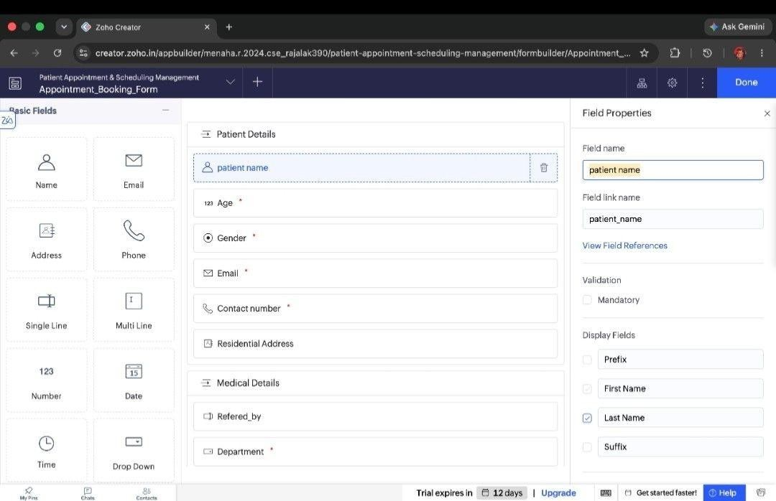
Fig 1: Form builder – Patient Details section with field types and mandatory fields
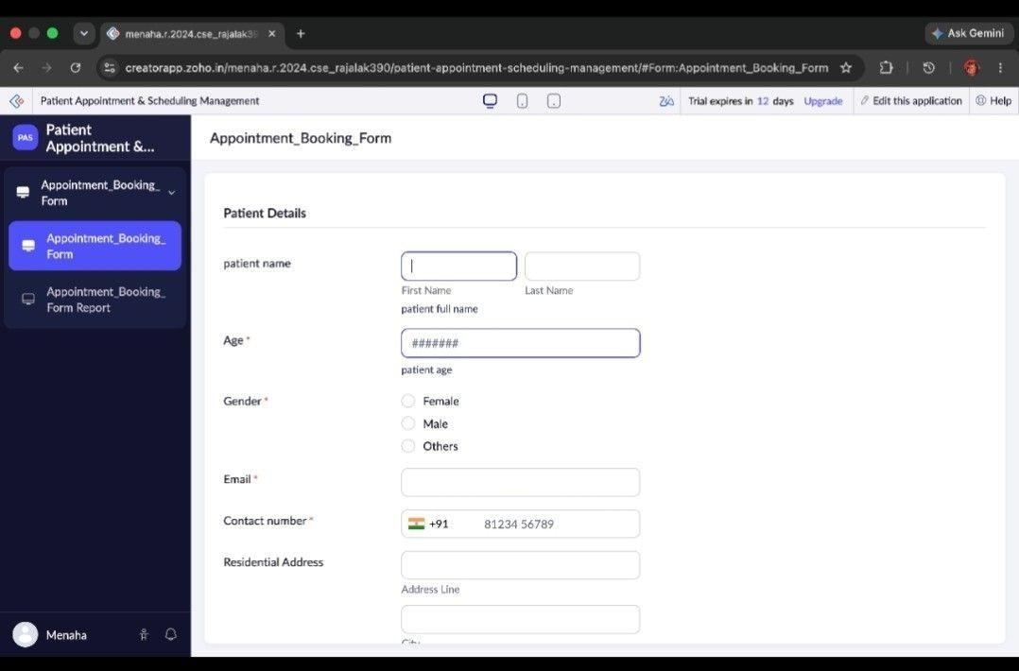
Fig 2: Form preview – Patient Details (name, age, gender, email, contact number, address)

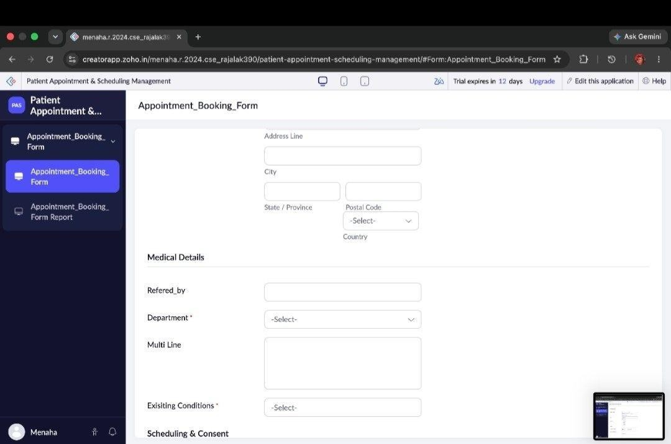
Fig 3: Form preview – Address and Medical Details section
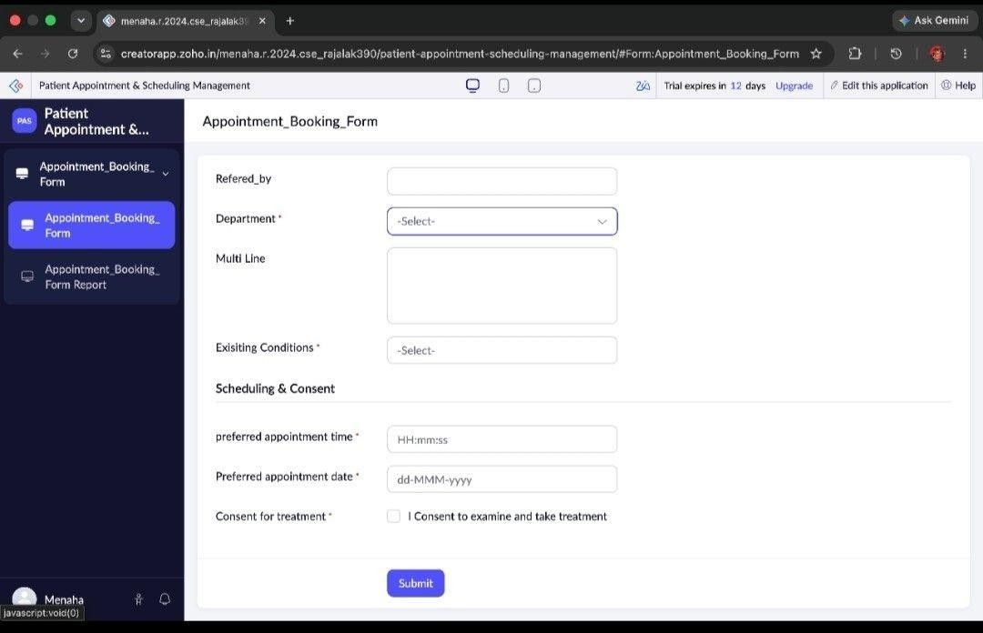
Fig 4: Form preview – Scheduling & Consent section with Submit button

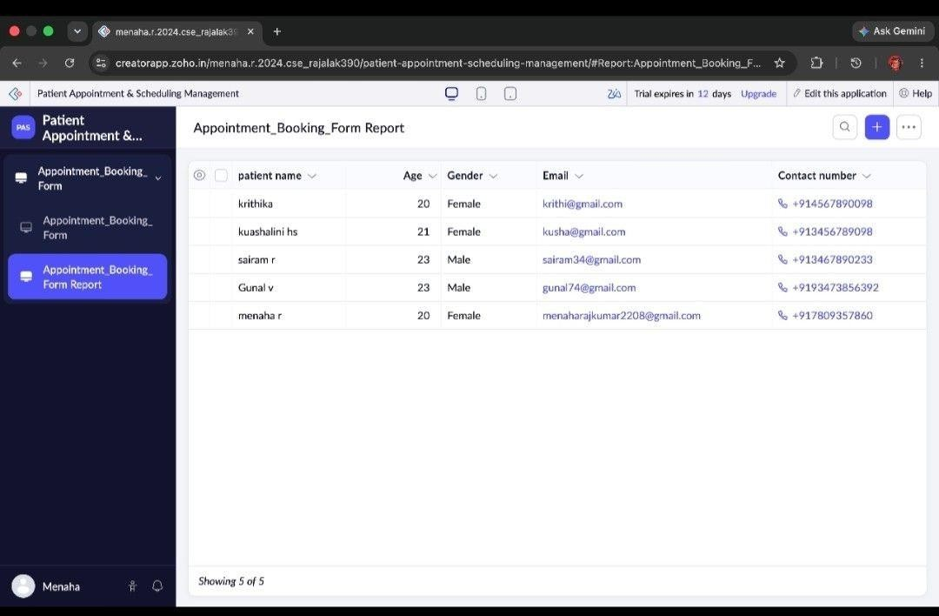
Fig 5: Appointment_Booking_Form Report showing 5 patient records
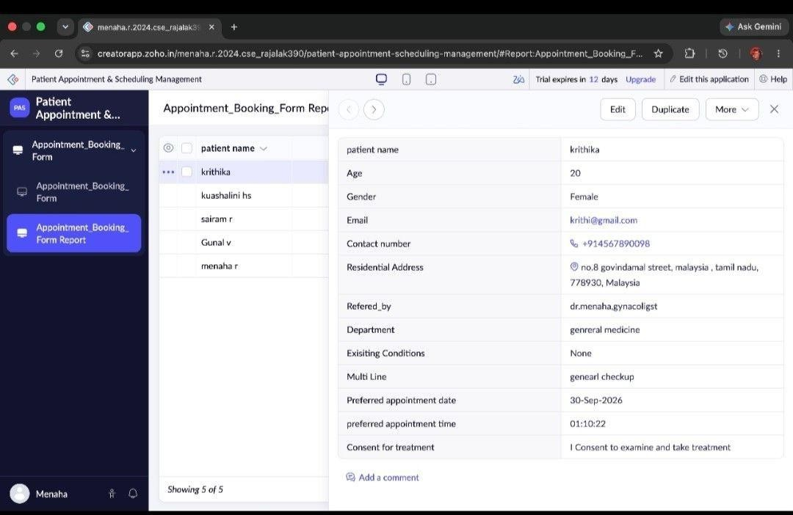
Fig 6: Detailed record view of a patient appointment (record 1)

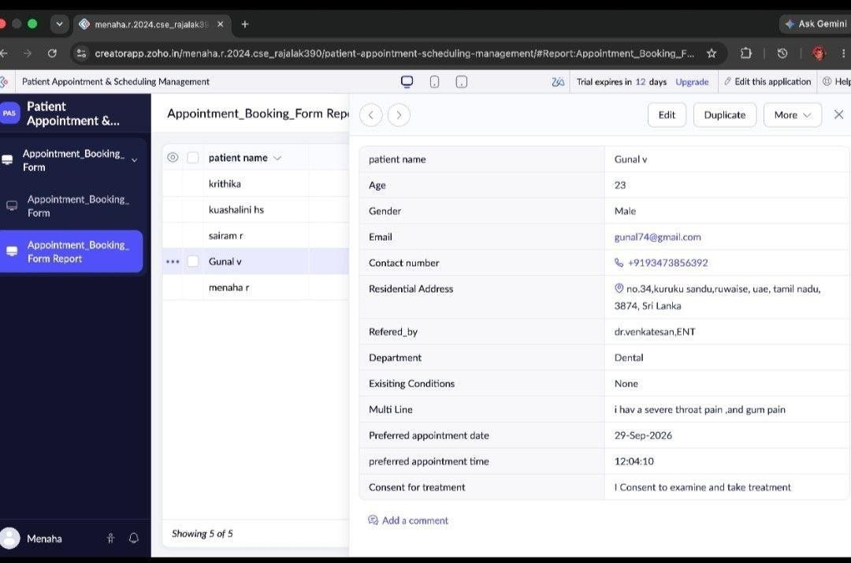
Fig 7: Detailed record view of a patient appointment (record 2)

RESULT
Thus, the Appointment_Booking_Form with Patient Details, Medical Details, and Scheduling & Consent sections was successfully created in Zoho Creator and sample patient appointment data was stored successfully.

